Hymn: I come with joy (verses 1-2) 530

Prayer of Thanksgiving: Pour out your Holy Spirit on all gathered here, that we might be your light in the world. Pour out your Holy Spirit on these gifts of bread and wine, that we might be infused with the gift of your nourishing guidance. Transform us with your nourishing grace, even as we eat of this bread and drink of this wine. Transfigure us to be your presence in the world, even as we are redeemed and reclaimed by your great love. By your Spirit, make us one with Christ, one with each other, and one in ministry to the world, until Christ comes in final victory, and we feast at the heavenly banquet. Through Jesus Christ, with the Holy Spirit in your holy Church, all honour and glory is yours, almighty God, now and forever more. (Continue in prayer)
Hymn: I come with joy (verses 3-5) 530
Communion

Prayer following communion

Hymn: Lead me Lord 575

Give us strength, courage and love to sink into a deeper silence with you, into moments of meaning, to glimpses of your glory. Lead us to the mountain top; entwine our lives with yours. We want to be with you.
We go in peace to love and serve the Lord,
in the name of Christ. Amen.

Irenaeus, 2nd century
"The glory of God is a human being fully alive; and to be alive consists in beholding God."

WELCOME TO…

The Presbyterian Church of
Saint David February 10, 2013

___________________________________________________________

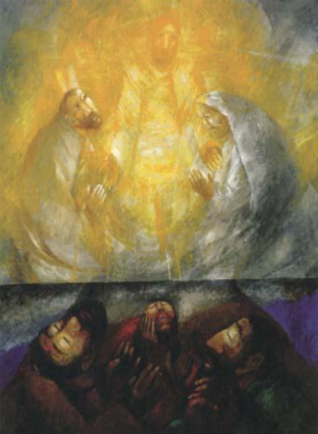

FOCUS: Today we find ourselves in an in-between time – we are at the climax of Epiphany and in anticipation of Lent and the question remains: ‘who is Jesus Christ?’ The faith story of the transfiguration is yet another attempt to answer this crucial question.

Gathering: The Transcendent Light shines in the darkness of our soul. Be still. God’s Spirit is at home within us. Let us pray.
Holy God, Holy and Strong One, Spirit Transcendent, present to our inner silence, come, transfigure, transform us.
Hymn: Christ whose glory fills the sky 177

Prayer of Confession: Strip away every anxiety, every shameful memory,
every moment of failure and weakness, that for a moment, we may sit in Your Light, reflecting Your righteousness, saturated by the Sacred. Draw back the veil of our soul. Holy God, for a moment, fleetingly, may we sit alongside the cherubim, spirit with Spirit, singing Your praise without words. Be still. Be aware of God’s Presence around you and within you. God breathes in Your breathing; God’s Love is in your heartbeat. Be still, at rest, suspended in silence. Your Light, O God, hurts our eyes. In Your Light, our brokenness is apparent. We come here for Your renewing love, for the forgiveness that will sustain us through all the consequences of our wrongdoing, to be upheld by Your embrace, that we may smile again.

Luke 9:28-36 Now about eight days after these sayings Jesus took with him Peter and John and James, and went up on the mountain to pray. And while he was praying, the appearance of his face changed, and his clothes became dazzling white. Suddenly they saw two men, Moses and Elijah, talking to him. They appeared in glory and were speaking of his departure, which he was about to accomplish at Jerusalem. Now Peter and his companions were weighed down with sleep; but since they had stayed awake, they saw his glory and the two men who stood with him. Just as they were leaving him, Peter said to Jesus, "Master, it is good for us to be here; let us make three dwellings, one for you, one for Moses, and one for Elijah" - not knowing what he said. While he was saying this, a cloud came and overshadowed them; and they were terrified as they entered the cloud. Then from the cloud came a voice that said, "This is my Son, my Chosen; listen to him!" When the voice had spoken, Jesus was found alone. And they kept silent and in those days told no one any of the things they had seen.
Continuing the Conversation: We've come to the end of the season of Epiphany, when we're particularly attuned to the times that God is manifest in the life of the world. Here on the edge of Lent, as we turn with Jesus toward Jerusalem and the mount of Calvary, we pause on another mountain for one of those "peak experiences" as sought after by post - Enlightenment, scientifically minded folks as by those who call themselves "post - modern." What is that about, that deep human longing to taste, however briefly, the transcendence of God? Peter, James, and John got much more than a brief taste. They had one of those ecstatic experiences that might have transformed their lives then and there, except that they didn't know what to do with it when it happened. Sleepy - headed Peter practically babbled, "not knowing what he said" (9:33), offering to put up tents and preserve the experience. We are sure that he was, of course, only trying to be helpful. Those of us who think that every situation requires us to DO something, however well - intentioned our efforts, are called back to faithfulness (and perhaps simplicity) by the voice of God in the story: "This is my Son, my chosen, listen to him!" As usual, however, Peter is very much like us. We often try to talk our way into understanding, to process an experience so that we make its meaning part of who we are. But this story is, first, about Jesus and who Jesus is, and the disciples are invited into an incredibly intimate moment with him. In the midst of teaching and healing, Jesus has called his followers to stop and pray, to be open to and strengthened by God's unexpected and indescribable grace, instructed by the voice of the Still-speaking God, and empowered to continue on the path of Jesus, no matter where it leads.

Hymn: Lord in this broken world 723
Intercessory Prayers Sisters and brothers, Jesus takes us to the very mountaintop to behold the world as does God. It is from this vantage point we pray today (John leads in prayer)
Invitation: When Jesus poured the wine, and the bread was broken, the world was changed, transfigured, completely the same yet fmade wholly new - the table around which we gather became a foretaste of love made real and of a world made whole.

